Ideation Phase
Define the Problem Statements

Date | 26 June 2025
Team ID | LTVIP2025TMID34134
Project Name | Pollen's Profiling: Automated Classification of Pollen Grains
Maximum Marks | 2 Marks

Customer Problem Statement Template:
As a researcher/doctor/agronomist, I need a faster and more reliable way to identify and classify pollen grains because manually analyzing them under a microscope is time-consuming, error-prone, and requires expert knowledge. This slows down my ability to make timely decisions—whether it's diagnosing allergies, monitoring biodiversity, or managing crop pollination. I often struggle with inconsistent results and lack of access to automated tools, which makes my work harder and less accurate. If I had a simple, AI-powered system that could automate this process, I could focus more on insights and action rather than tedious data analysis. 
Example: 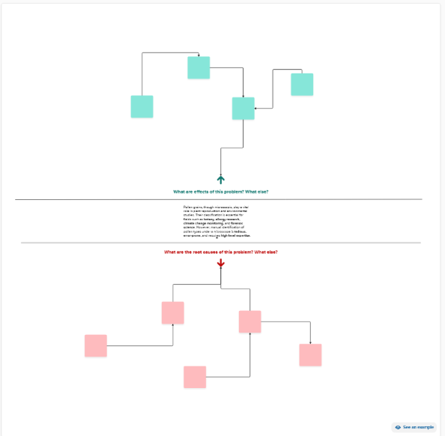

Problem Statement (PS) | I am (Customer) | I’m trying to | But | Because | Which makes me feel
PS-1 | Identification | Find | image | Scanning | Prediction
PS-2 | recognition | Verify | Data | Scanning | Prediction

